**Introduction to GIS**

**Assignment Week 07**

This week is our halfway point, normally a “Midterm” week. We will have 2 problems which reinforce our skills and a quiz (not a midterm). It will be a mostly “on your own” set of problems, since we’ve done them before.

1. **Hudson Valley**

Create a map of the Hudson Valley (New York counties only). These are the counties which either border or have the Hudson River running through it. This is similar to the “I-684” and Hospitals problem in which we do selection of counties by location – those that are intersected or border Hudson River

**Layers needed:**

* New York State Counties
* New York State Water Bodies

**New York State Counties**

1. Navigate to the US Census Tigerline Data website: <https://www.census.gov/geographies/mapping-files/time-series/geo/tiger-line-file.html>
2. Go to the *Web Interface* – near the bottom in green.
3. Select year: 2010
4. Select a layer type: *Counties and Equivalent*
5. In the second dropdown menu select New York – Select Download
6. Copy the downloaded file to your folder for Week07 and unzip

**New York State Water Bodies**

While Tigerline water data is by state, it doesn’t contain an attribute that names the Hudson River. We will use the USGS National Map.

1. Navigate to the USGS National Map.

<https://nationalmap.gov/small_scale/atlasftp.html?openChapters=chpwater#chpwater>

1. Select *Water*
2. Download the shapefile for ”Streams, One Million-Scale”, March 2014
3. Move to your folder for this week (Week07), and unzip (twice).
4. NOTES:

* This is a big file of the entire US. We’ll pull out New York State with a Selection by Attribute.
* The format is *.tar.gz* – you have to first extract the .tar file, and then shapefile.
* Once the extractions are done, to save space you can remove the *.tar* and .tar.gz files.

1. Start ArcMap with a new map; set the data frame coordinate system to NAD83, Map properties for “Relative Path Name”
2. Only add the Water layer to the map (streaml010g.shp). You will see a US Map of water only.
3. Check the Attribute table and notice that there are two attributes (*State* and *State_FIPS*) we can use for selecting New York State. *State* is probably easier.
4. Using Select by attribute select the Water features for New York State (“State” = ‘NY’)
5. Create a layer of selected features (right-click the layer->*Selection*)
6. Export the new selection layer as a *shapefile* (right-click the layer->*Data->Export Data*).
7. Name the new New York State shapefile NYSWater.shp
8. Once the new layer is added to the map, you can remove the original US Water layer and the Selection layer. If you zoom to layer (right-mouse click->zoom to layer) it will fill the panel.
9. Save the map as yourlastnameHudsonValleyCounties.mxd
10. It should look like this:

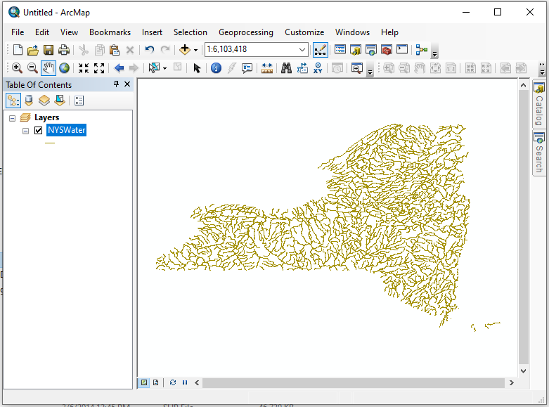

1. Add NYS Counties layer (make sure it is below the water layer)
2. Create a map of the counties in the Hudson Valley.
   * 1. Select by location using “Intersection…”
     2. Create a layer
     3. Add the annotations/title/legend/etc. to make the map publishable
     4. Rename layers and legend for readability
     5. Modifiy colors and symbol sizes (if necessary) for readability
     6. Export as *yourlastnameHudsonValley.jpg*
3. Save the map

**Proximity of Gas Stations**

This is similar to the Hospitals Proximity exercise.

Suppose I’m looking for a house in Westchester County and want to make sure that the location of the house is more than 500 feet from a gas station (I’m worried about environmental accidents). I’m going to create 500 ft. buffers around the Gas Stations.

1. In your Week07 folder, gather layers for
   1. Westchester Towns (“subdivisions”). You don’t have to download from Tigerline. but can copy the zip file that we had already downloaded from Week 05 (*tl_2010_36119_cousub10.shp*). Copy to this week’s folder (Week07) and unzip
   2. Westchester Roads. You do not have to download the layer from Tigerline, but can copy the zip file that we had already downloaded from Week 05 (*tl_2010_36119_roads.shp*).

Copy to this week’s folder (Week07) and unzip

* 1. Similar to the Hospitals layer, download Gas Stations from Westchester GIS to your Week07 folder and unzip it (<https://giswww.westchestergov.com/wcgis/DataWarehouse.htm>)

*County Data Download -> Community Facilities -> Gas Stations Shapefile*

1. Open a **new** map in ArcMap; load the layers Towns, Roads, and Gas Station Layers.
2. Save the map as *yourlastnameGasStations.mxd*
3. Turn on layers for the Towns, Roads, and Gas Stations
4. Make sure all the layers are visible.
5. You may want to change the “symbology” to make the Gas Stations more visible (color, size shape). If you click on the symbol, the color/size palette opens (you can change size and color)
6. Create a Buffer layer for Gas Stations in the same way you created the buffer around I-684:
   1. Open the Toolbox
   2. Analysis Tools -> Proximity -> Buffer
   3. Input: Westchester Gas Stations
   4. Output: Navigate to your folder: GSBuffer
   5. Linear Unit: 500 Feet (in the pull down)
   6. Ok
7. A Buffer layer should be added to the map.
8. NOTE: You will have to zoom in to see the buffers.
9. The order of the layers should be Gas Stations, Westchester Roads, Gas Station Buffer, Westchester Towns.
10. Make sure you are zoomed in to where you can see a few of the Gas Stations and the surrounding buffer.
11. Turn on the Roads labels (if you are zoomed in enough it won’t be cluttered).
12. In Layout View, set the map up for publishing with Title, etc.
13. Export a .jpg of the new map (*WestchesterGasStations.jpg*).
14. Save the map (*yourlastnameGasStations.mxd)*

**What is due this week (10/22/2019)**

Upload the 2 jpgs in a single word document: yourlastnameSelectionReview.jpg

*yourlastnameHudsonValley.jpg*

*yourlastnameWestchesterGasStations.jpg*

1. Take the quiz